

ECE371 Design of Digital Circuits and Systems
Winter 2019

Lab 4 - Bit Counter and Binary Search Algorithm Implemented in FPGA

Student: Jeff Josephsen
Professor: Dr R. Hussein
February 23rd, 2019

Abstract:

The purposes of this laboratory assignment was to investigate the use of the Algorithmic State Machine (ASM) Chart as a thinking tool in the design and implementation of a Bit Counter Algorithm and a Binary Search Algorithm. The implementation of these algorithms and their testing were completed both in software on Quartus Prime Lite Edition with data verification testing in ModelSim and in hardware on the Field Programmable Gate Array (FPGA) side of the Cyclone V chip of the Altera DE1-SOC development board with the data verification testing by SignalTap II Logic Analyzer. Significant amounts of debugging occurred during the completion of the lab. More than half of the debugging time was spent in efforts to make the software tools work correctly. At the end of the lab all parts of the software and hardware worked correctly as was demonstrated to assistant staff.

Introduction:
I have heard it said that the Algorithmic State Machine and Datapath or ASMD method for modeling processes will be increasingly necessary for the design and implementation of firmware as design requirements become more complex. This laboratory assignment served as an introductory point where I, as a student, could become comfortable with the ASMD model in the basic bit counting algorithm of task one and the more complicated binary search algorithm of task two.
A background on the ASMD model was given in lecture and also in the laboratory directive. A discussion of the different elements included state boxes, conditional tests, mealy output ovals, transitions by arrows, and implied timing.
In the first task students were given a simple ASM chart for bit counting. This chart can be seen in the following image.
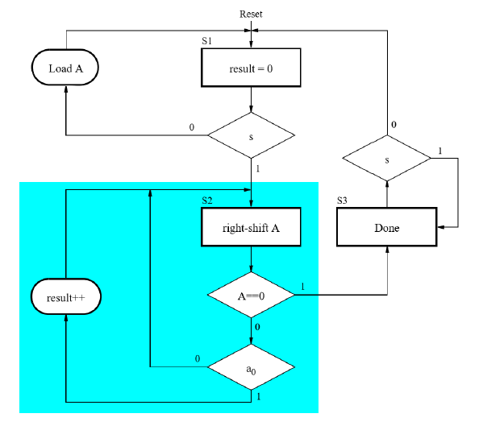
Hardware input sources such as a clock input and user switch input sources were clarified to the students. The laboratory directive required that the students write modules that included the use of finite state machine control and datapath thinking. From this point the students were asked to implement this algorithm in software and hardware.
In the second task the students were asked to implement a binary search engine algorithm in software and hardware. Again the students were asked to design with the use of Control and Datapath design considerations and to instantiate a Memory Module that would connect to the Datapath module. The following image was provided to the students to clarify the expected layout of the program.
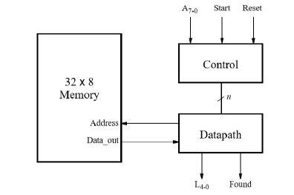

Again, hardware input sources such as a clock input and user switch input sources were clarified to the students. It was also required that a Memory Initialization File (.mif) be used to initialize data to the memory. From this point the students were asked to implement this algorithm in software and hardware.

Procedure and Results:
What were you testing or designing? What did you actually do? Give good in-depth discussion
of your design and your code, and describe your process. List any equations you used or
techniques you employed. This will be what takes up the majority of pages in your report.
Include any relevant graphics or pictures to help make topics clear.
Steps to complete the lab
Description of each module (explain how they work and point out code, ect)
Simulations of each module with comments on important things to notice about them.
Screenshots of the code
Screenshots of the modelsim
Screenshots of the flow summary.
Screenshots of the signaltapII.
Here, present and discuss your findings. Explain them, and how (or if) they differed from the
expected. Use graphics to help elucidate your results. Answer any questions raised in the lab
report. Also use this section to talk about any known errors in your lab, or any challenges you
faced.

Overall Description of what the finished product was/how it behaved.
Discussions of any problems had while completing the lab, or unsolved errors.

In task 1, the design and implementation a bit counting algorithm, four SystemVerilog modules were used. The first was a top level module where each of the subsequent module was instantiated and connected to the hardware data lines of the development board. Also, a test bench was written to verify the correct working of the system. The following image shows the top level module and testbench SystemVerilog code that was written.
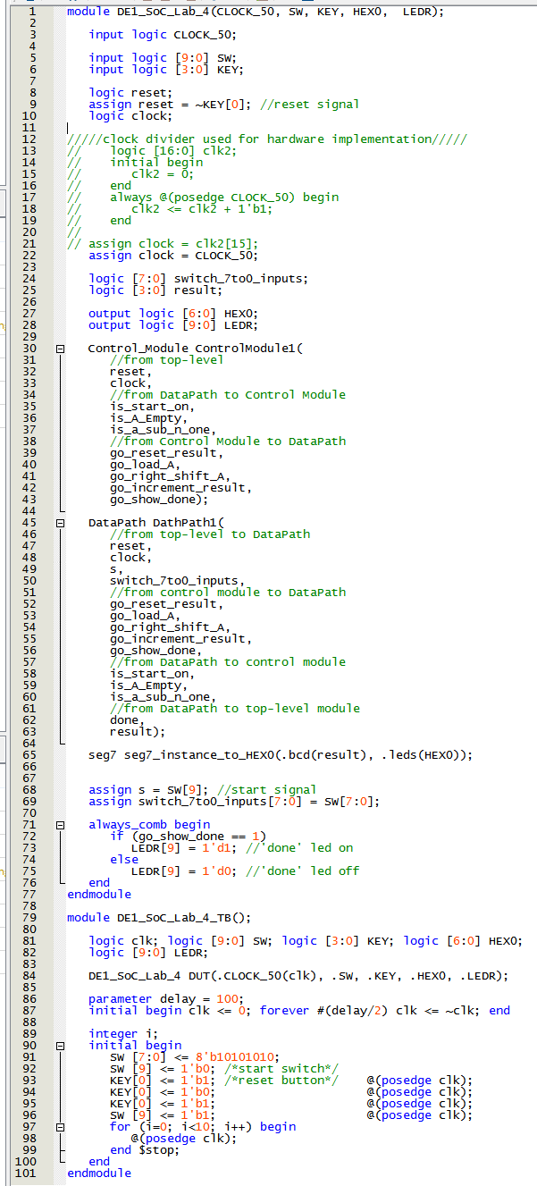

Instantiated by that module were the ControlModule1 and the DataPath1. The control module was used for resetting the system, controlling next state logic, and calculating appropriate directives from the control module to the datapath. I have included an image of the Control Module code as follows.

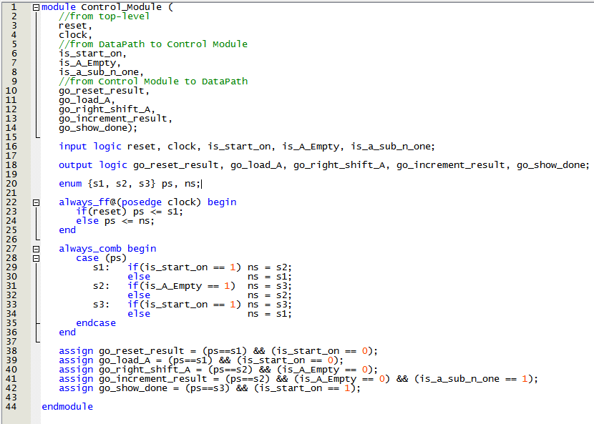

The assign statements found at the bottom of the Control Module are sent to the Datapath and give directives for the computing of data. I have inserted an image of the Data Path Module below.

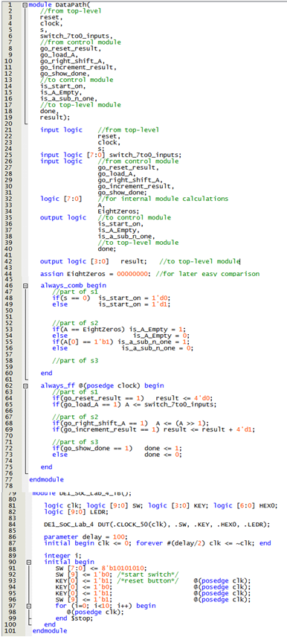
Lastly, for purposes of displaying the number of true bits found in the count a seven segment display module was instantiated by the top level module. I have included a copy of this module below.
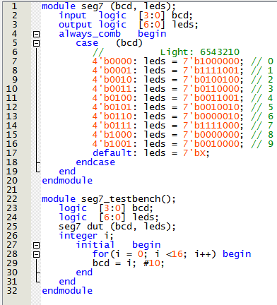
All of these modules were tested in ModelSim software and the resulting datalines can be seen in the following image.

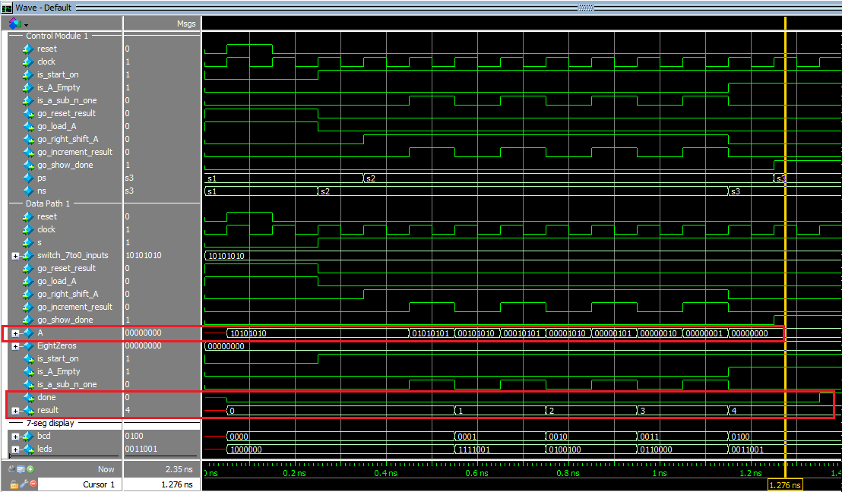
The system was also loaded to the hardware development board, and aside from the corrected bugs mention in the conclusion of this report, the system operated as expected when demonstrated to assistant teaching staff.
The following is an image of the Flow Summary from the full compilation and synthesis of the system.
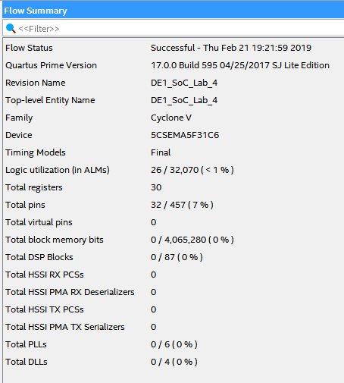
In task 2, the design and implementation a binary search algorithm, an ASM was designed and four SystemVerilog modules were created. The first was a top level module where each of the subsequent module was instantiated and connected to the hardware data lines of the development board. Also, a test bench was written to verify the correct working of the system.

This Binary Search Algorithm would receive from user input a string of bits, and then search for that string of bits in sorted memory by beginning in the middle of the memory and then asking if the data at that memory location is more or less than the memory being searched for. The process would then iterate on the upper or lower half of the memory block. This process would continue to cut the ranges in half until the data was found or until the search was completed without finding the data.

This task called for the student to create an Algorithmic State Machine block diagram to aid in the design of the system. The ASM I designed is found in the following image.

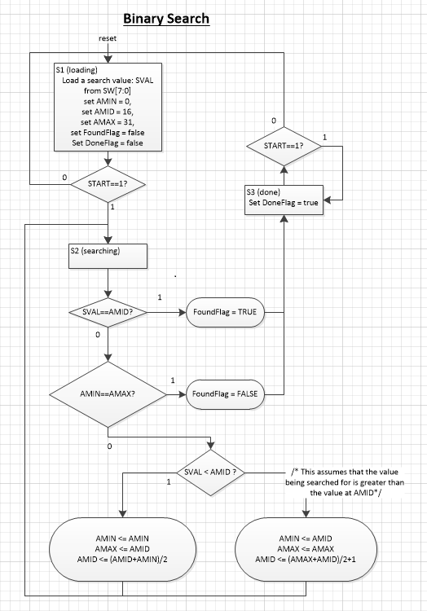

Prior to settling on this design, and especially the parts regarding the reassignment of AMIN, AMID, and AMAX in the lower ovals, I spent considerable time walking through the algorithm by hand.

I then began coding the module. The following image shows the top level module and testbench SystemVerilog code that was written.
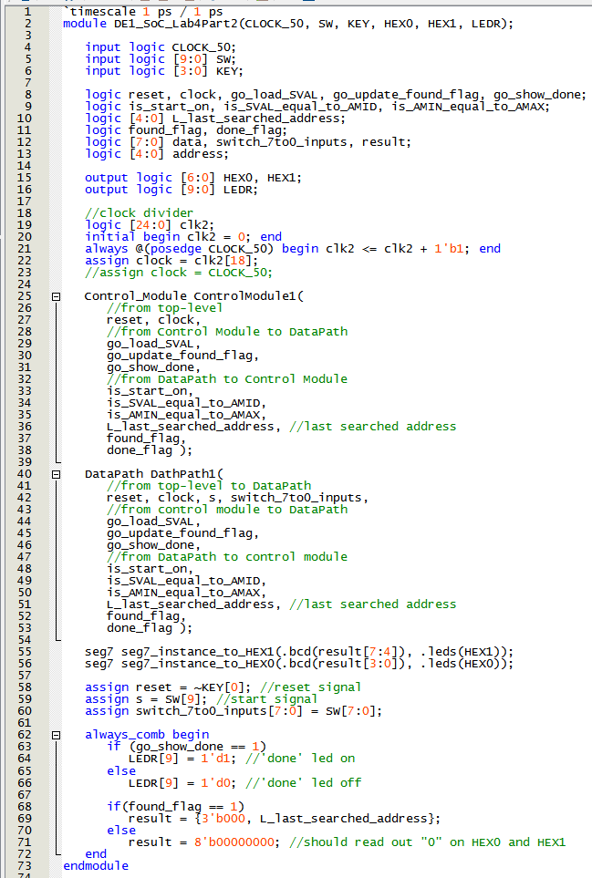
This top level module instantiated and connected other modules together and to the hardware. The other modules included a control module, datapath module, a 7 segment display module, ram creation module, and a test bench module.
The control module was used to direct the data path module in to appropriate states and with statements such as go_update_found_flag. This can be seen in the following image.
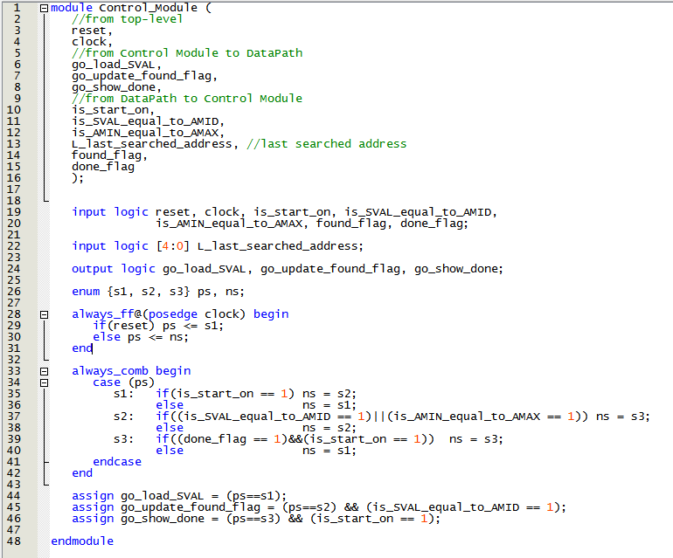
The datapath module was used to step through the processes of the binary search algorithm and to keep track of address, search result data, and such. A copy of the datapath algorithm can be seen in the following image.
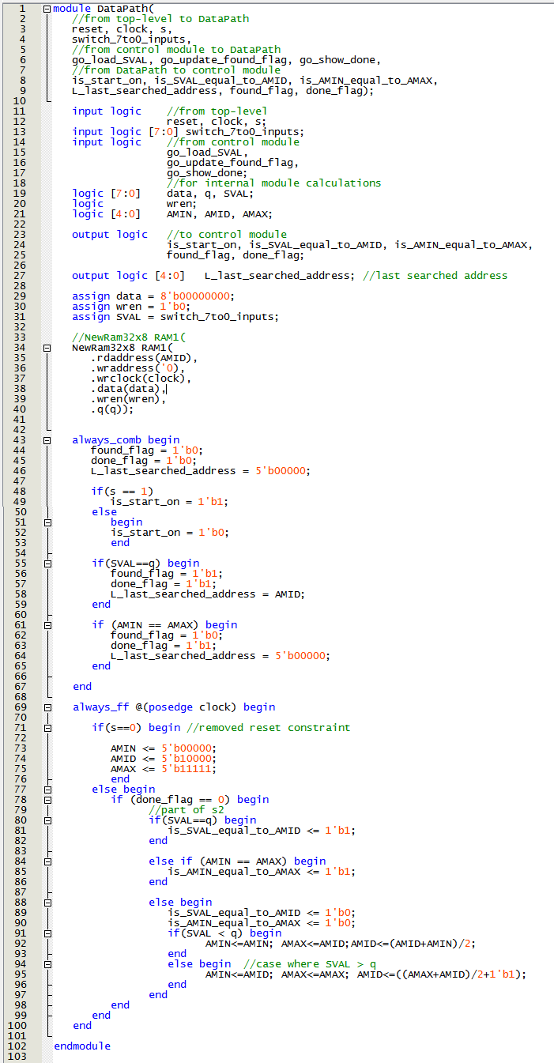
The other modules, including the memory module, seven segment display, and test bench were also utilized and the following ModelSim results were found from the SystemVerilog System.
In the following image you can see in the yellow boxes that we were searching for the value "00000001" I had initialized the memory such that the data held in each of the 32 words matched the address of the memory cell. The data could have been initialized to any sorted values between 0 and 2^8. This seemed the simplest way to go for design.
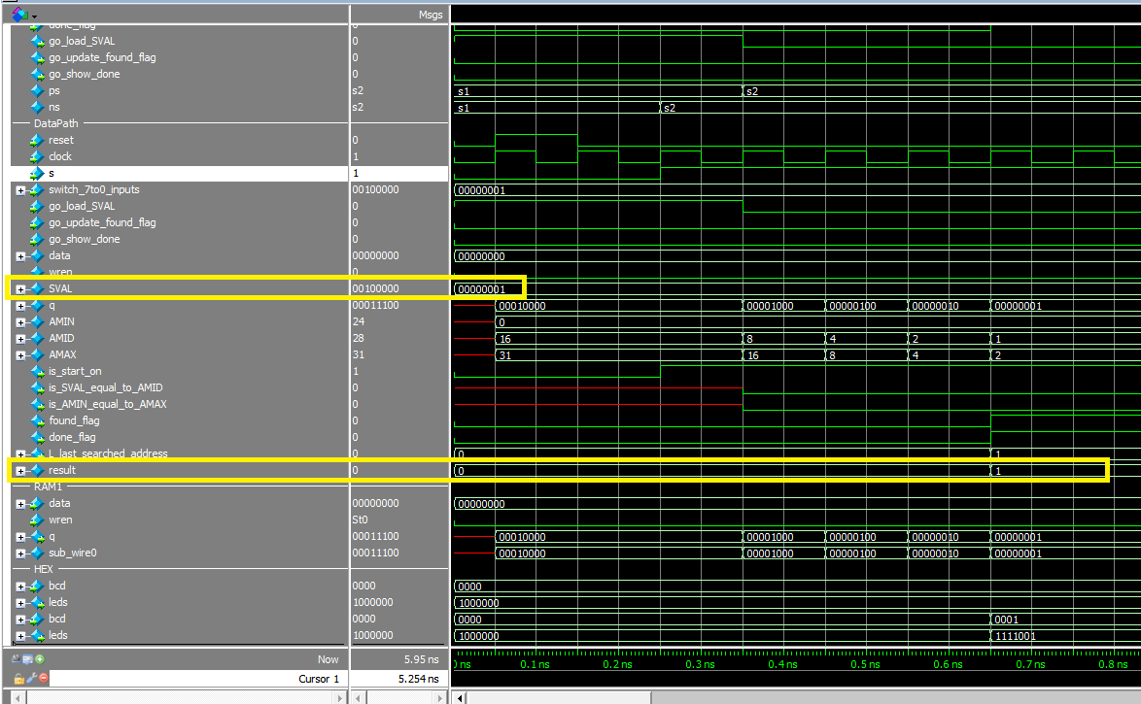
After verifying that the code was working properly, and adjusting the clock in the code with a clock divider, I uploaded the code to the development board. The following image is a snapshot of the SignalTap readout from the datalines of the hardware.

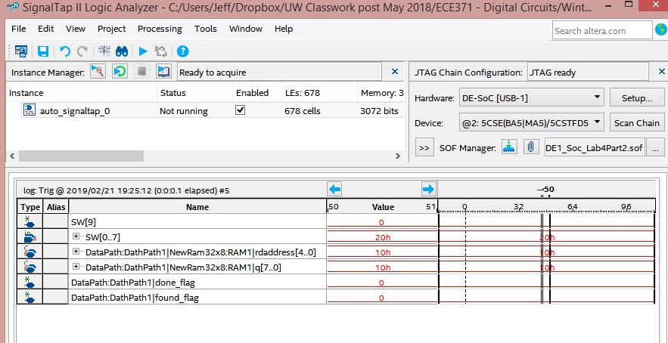
Lastly, I have included here a copy of the post compilation and synthesis flow summary of the Binary Search Algorithm.
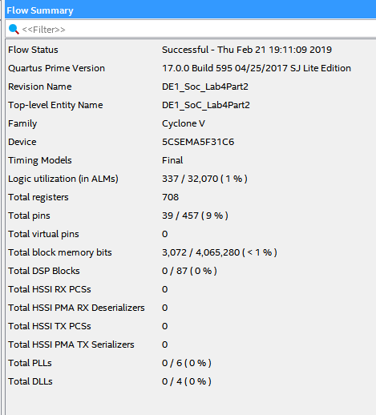
The system, ModelSim, and SignalTap outputs were demonstrated to work as required and approved as working appropriately by Assistant Teaching Staff.
Conclusion:

Finish your report with a discussion about what skills were gained in this lab. Tie the report
together with a good ending.
A final Summary
Reflections on the lab or what was learned.
Number of hours worked (estimated) to complete this lab assignment. Be sure to include reading, planning, designing, coding, debugging, testing, writing the report, ect.
Submit a pdf and a compressed folder of the source files.

There were a number of bugs encountered. The bugs were mostly caused by the tools and not in the code. Here is a short summary of them.

Bug #1. Creating a Quartus Prime Lite Edition project with the correct settings for the project and the programmable device. It is very easy to create a project with the wrong settings. There are many settings to remember.

Bug#2. Creating a Quartus IP-based memory module from the wizard that was set-up to load the array.mif (memory initialization file). It is very easy to skip the small part of the set-up where the module is told which .mif file to include in compilation.

Bug #3. There was a hardware specific timing issue; which was experienced by most groups, where there was an deficiency in set-up slack for the bit counter and the binary search algorithm. In both cases a clock divider was necessary. For the purposes of uploading to the board the clock for the program was run at least as slow as once tick for each 15th bit change of the CLOCK_50 50 MHz signal of the board. Also, it became important to keep in mind when returning to a debugging in software with ModelSim that the code needed to be switched back to the initial clock settings so that the ModelSim clock would be run without waiting for 30,000+ ticks..

Bug #4. Timing issue wherein memory request returns were happening at the next clock edge rather than immediately. Value comparisons were not happening at the correct times. This could have been resolved in one of two ways. either by adding extra registers for appropriate delays or by use of a type of IP catalog memory that allowed for return of data from memory asynchronously. This would allow for a return of memory contents with immediacy rather than at the next positive clock edge. The latter approach was suggested by Assistant Teaching Staff and did suffice for a correct fix.

Also, I would have benefitted from some discussion of best practices when laying out the modules. In some of the lecture material the Control Module and Datapath are laid out in separate modules, and in others they are laid out in the same SystemVerilog module. The first coding practice requires a lot more passing of variables and benefits the coder with a clear way of seeing the structure of the system. In the latter method, where the Control Module and Datapath are in the same module the variables are less complicated to employ, but the flow of the program is not so well clarified back and forth between SystemVerilog Modules. I would like to know if there is an opinion of the best way to do this.

Regarding TAs. They we very very attentive and very very helpful. I am surprised that they worked so hard. However, they were also swamped by student requirements. During the two days before the due date of the lab demonstrations waiting times to ask questions of the TA came to more than an hour. I was told by a TA, "Jeff there's a line. You need to put your name on the waiting list." I share this to give a snapshot of the situation in the lab this week. Many students aren't done yet simply for a lack of TA time resources.

In all I would say that this was not an easy lab, but was very instructional. I feel that I learned a great deal and appreciate the opportunity to participate.

This lab work took approximately 35 hours to complete.

References:
Include a separate page of any resources you may have used to help you in the lab.

